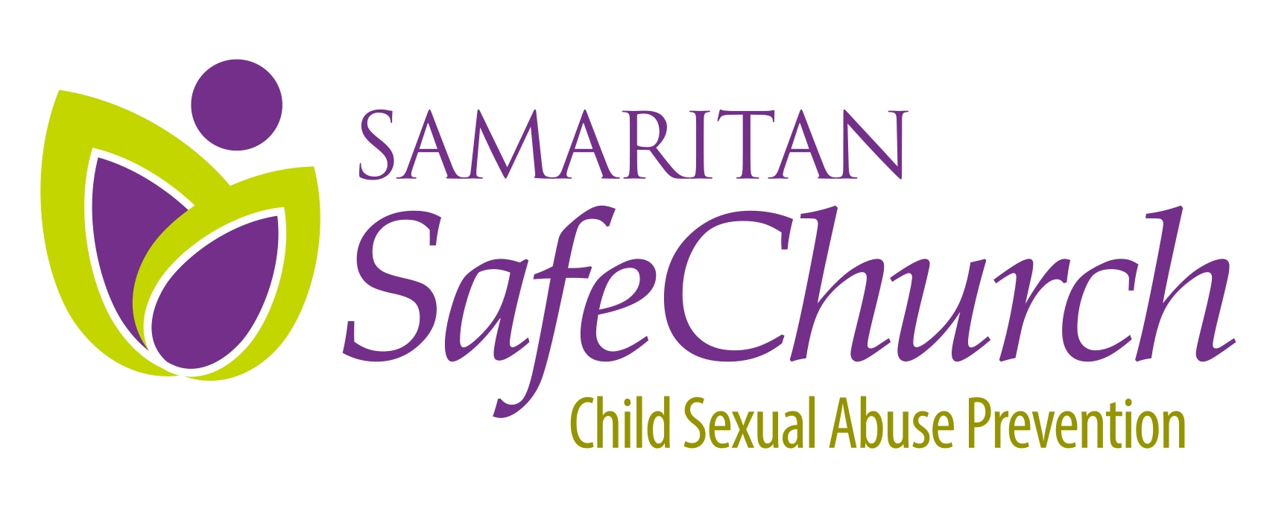
NEWS YOU CAN USE!
Updated August 25,2015

Certifications for those working with children

Effective 12/31/14: Current employees in positions as an “employee with a program activity or service, as a person responsible for a child’s welfare or having direct contact with children” must have three specific certifications dated within the past 60 months. All current employees must have the specified certifications in place no later than 12/31/15.

Effective 12/31/14: Prospective employees may use current certifications, or may be hired on a provisional basis for a single period of no more than 90 days, provided the employee and employer have met all conditions set forth for such provisional hires, including 1) Application for the three specified certifications, 2)The applicant not be permitted to work alone with children, and 3) The applicant must work in the immediate vicinity of a permanent employee, until certifications are obtained. They must also sign a “Swear or Affirm” statement.

Effective 8/25/15: Prospective volunteers (those who are not current volunteers working with children) must have all the required background checks in place prior to working with children (adults only). They must also sign a “Swear or Affirm” statement.

Effective 7/1/16: Current volunteers (those serving prior to 8/25/15) who “volunteer with a child-care service, a school or a program activity or service as a person responsible for the child’s welfare or having direct volunteer contact with children” are required to have specified background checks dated within the last 60 months no later than 7/1/16 (adults only). They must also sign a “Swear or Affirm” statement.

The background checks required are specific, and it is not legally sufficient to use a screening service that does NOT include the clearances listed below. A “national criminal data base” search, or “Sexual Offender registry check” may be used but they cannot substitute for the clearances listed below.

- Required certification For Employees & Volunteers
Pennsylvania State Police Request for Criminal Record Check Form (SP4-164) ($8 employees, free volunteers)
Obtain information and download paper form at
http://www.dhs.state.pa.us/findaform/childabusehistoryclearanceforms/index.htm
OR go to E-Patch and apply on-line at https://epatch.state.pa.us/Home.jsp.

- Required certification for Employees & Volunteers:
PA Child Abuse History Clearance) ($8 employees, free volunteers) –Applicants may submit a paper form with a money order or business check (not a personal check), and also have the option to use electronic submission, and pay with a credit card. Obtain information and download paper form at
http://www.dhs.state.pa.us/findaform/childabusehistoryclearanceforms/index.htm
and submit to:

ChildLine and Abuse Registry
Pennsylvania Department of Human Services
PO Box 8170
Harrisburg, PA 17105-8170

- Once a paper application is received, the results will be mailed to the applicant’s address that was noted on the application within 14 days from the date that the application is received in the ChildLine Verification Unit.
OR use the new PA Portal for mandated reporters and get this clearance on line at
https://www.compass.state.pa.us/cwis/Public/home
- Creating an account and submitting your certification application online will give you immediate access to your results or the status of your results if your results cannot be processed immediately.

Organizations who want to set up business accounts must first register for a Business Partner User account using the “Organization Account Access” link on the Child Welfare Portal. Organization accounts will allow businesses and organizations to purchase child abuse history clearance payment codes and distribute those codes to applicants. When an applicant uses a code given to them by an organization, the organization will have access to the applicant’s child abuse history clearance results once those results are processed.

- Required certification for all Employees and for Volunteers not living in PA for the past 10 years
FBI Fingerprint Record certifications ($27.50 - $28.50)

If the volunteer has lived within PA for the past 10 years, no fingerprinting is required; however, the volunteer must swear or affirm in writing they are not disqualified from service based on a conviction of an offence under 6344. (Samaritan SafeChurch policies include a “swear or affirm” form you can use)

- The Pennsylvania Department of Human Services is utilizing Cogent Systems to process fingerprint-based FBI criminal background checks. The fingerprint based background check is a multiple step process. For more information and to begin the registration process, go to www.pa.cogentid.com//index_dpw.htm. No paper forms are available!
- The Pennsylvania Department of Education also utilizes Cogent Systems to process finger print based FBI criminal background checks for prospective employees of public and private schools. Under Act 114 of 2006, ALL prospective school employees, school contractors and student teachers are to use the Pennsylvania Department of Education system. This includes but is not limited to: Teachers, School Administrators, Substitute Teachers, Teaching Assistants, PIAA Sports Officials, School Bus Drivers, and Student Teachers. Applicants may register online at: www.pa.cogentid.com/index_pde.htm
If the volunteer is going to be using the certification for a school as well, choose the Department of Education option online @ $27.50; otherwise choose the Department of Human Services option @ $28.75

- Caution: The changes in PA’s Child Protective Services Law in 2014 included a number of specific criminal and civil offenses that now automatically disqualify a person from paid or unpaid work with children. Be sure the person at your church or organization responsible for reviewing the results of the above clearances is aware of these “disqualifiers”.

Repeat Certifications
Employees (whenever hired) will be required to repeat all of these certifications every 60 months. Volunteers will only need to repeat the PA certifications every 60 months. (In other words, a volunteer who has still not lived in PA for 10 years when it is time to repeat clearances does not require a repeat FBI fingerprint check.)

Of Note:

THE PENNSYLVANIA CHILD ABUSE HISTORY CLEARANCE CERTIFICATE WILL NO LONGER BE ISSUED ON IVORY MARBLE SECURITY PAPER. ALL CHILD ABUSE HISTORY CLEARANCE RESULTS WILL BE ISSUED ON PLAIN WHITE PAPER AS OF DECEMBER 31, 2014.
VOLUNTEERS ARE NO LONGER REQUIRED TO SUBMIT A COPY OF THE PROCESSED RESULTS OF THEIR “REQUEST FOR CRIMINAL RECORDS CHECK” (SP4-164) FROM THE PENNSYLVANIA STATE POLICE OR A COPY OF THEIR FBI RESULTS WITH THEIR PENNSYLVANIA CHILD ABUSE HISTORY CLEARANCE APPLICATION. If copies are attached, they will NOT be returned.

7/15/15

